Flipper Zero Infrared Guide
Universal Remote & Learn New Remote Workflow
Beginner-friendly, step by step

Introduction
The Flipper Zero is a pocket-sized multi-tool for exploring digital signals, and its Infrared (IR) app turns it into a remote control for almost any TV, sound system, or air conditioner. This guide walks through the two ways the Flipper Zero can control a device with IR — instantly firing a built-in universal remote code, or learning and copying the exact signal from a remote you already own — with an on-device screenshot or real test photo alongside every step.

What You'll Learn
- Part A – Universal Remote: use the Flipper Zero's built-in code database to control a TV (or other device) immediately, with no physical remote required.
- Part B – Learn New Remote: capture and copy the exact IR signal from a physical remote you already own, so the Flipper Zero can resend it later.
Before You Start: You'll need a charged Flipper Zero and a clear line of sight to the device you want to control. For Part B only, you'll also need the original physical remote whose signal you want to copy. No soldering, apps, or extra hardware required.

Using Infrared (IR) to Control Devices
Infrared is the invisible light signal used by most TV, audio, and air-conditioner remote controls. The Flipper Zero can do two different things with IR: (A) act as a ready-made “universal remote” that already knows thousands of common TV/AC codes, and (B) “learn” a button from a physical remote control you already own, so the Flipper Zero can copy and resend that exact signal later. Both are covered below.

Step 1: Open the Infrared folder
- From the Flipper Zero's main file/app menu, you will see several folders such as Bluetooth, GPIO, Games, Infrared, and NFC.
- Highlight Infrared and press OK.
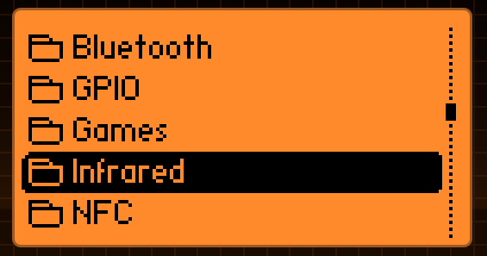
Figure 2.1 — The main app/folder list. Select “Infrared”.
- Inside, you will see the Infrared app itself listed. Select it and press OK to launch it.
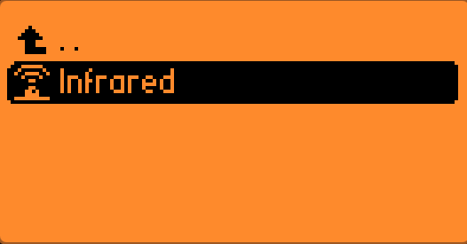
Figure 2.2 — Opening the Infrared application.

Step 2: The Infrared main menu
The Infrared app opens to a menu with four options: Universal Remotes, Learn New Remote, Saved Remotes, and GPIO Settings. This guide covers the first two.
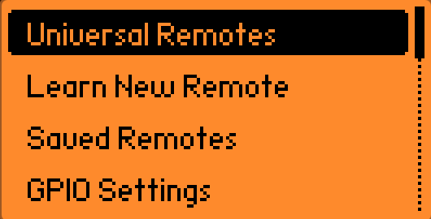
Figure 2.3 — The Infrared main menu.

Part A: Using a Universal Remote (no learning needed)
Universal Remotes let you try to control a device immediately, without first capturing a signal from a physical remote. The Flipper Zero cycles through its built-in database of codes for that type of device until the device responds (for example, the TV turns off or changes volume).

Step A1: Choose the device category
- From the Infrared main menu, highlight Universal Remotes and press OK.
- Choose the category that matches your device: TVs, Audio Players, Projectors, or Air Conditioners.
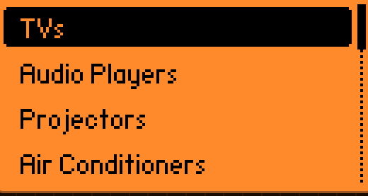
Figure 2.4 — Universal Remote categories, with “TVs” highlighted.

Step A2: Choose a saved/known remote or create one
On the next screen you can pick a remote profile you have already used before, or create a new one for the brand/model you are testing.
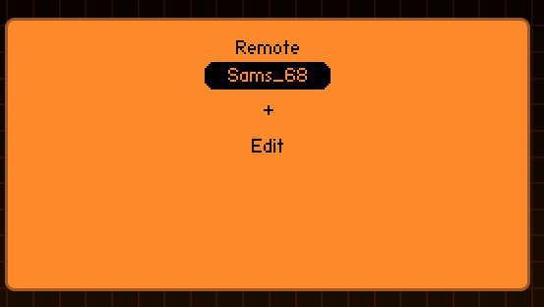
Figure 2.5 — Remote selector. “Sams_68” is a previously saved remote profile; “+” creates a new one; “Edit” renames or deletes one.

Step A3: Send signals until the device responds
Point the Flipper Zero's IR port (top edge of the device) directly at the front of your TV (or other device), then select a button (for example, Power). The Flipper Zero will rapidly transmit one code after another from its database.
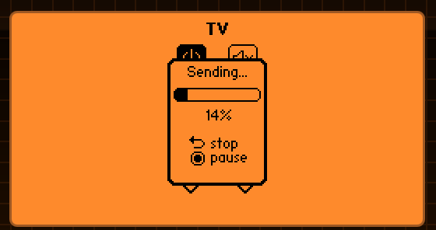
Figure 2.6 — Sending IR codes one after another (here, 14% through the list). Watch your TV — as soon as it reacts, select “stop” immediately.
Note: Keep the Flipper Zero pointed steadily at the device while this runs. It can take a little while to cycle through codes — you can pause and resume, but do not stop until you see the device react.

Step A5: Live test — confirming the TV actually responds
To verify the saved code genuinely controls the real TV, it is worth running a live side-by-side test against the original physical remote and watching the TV's screen change before and after sending the command.

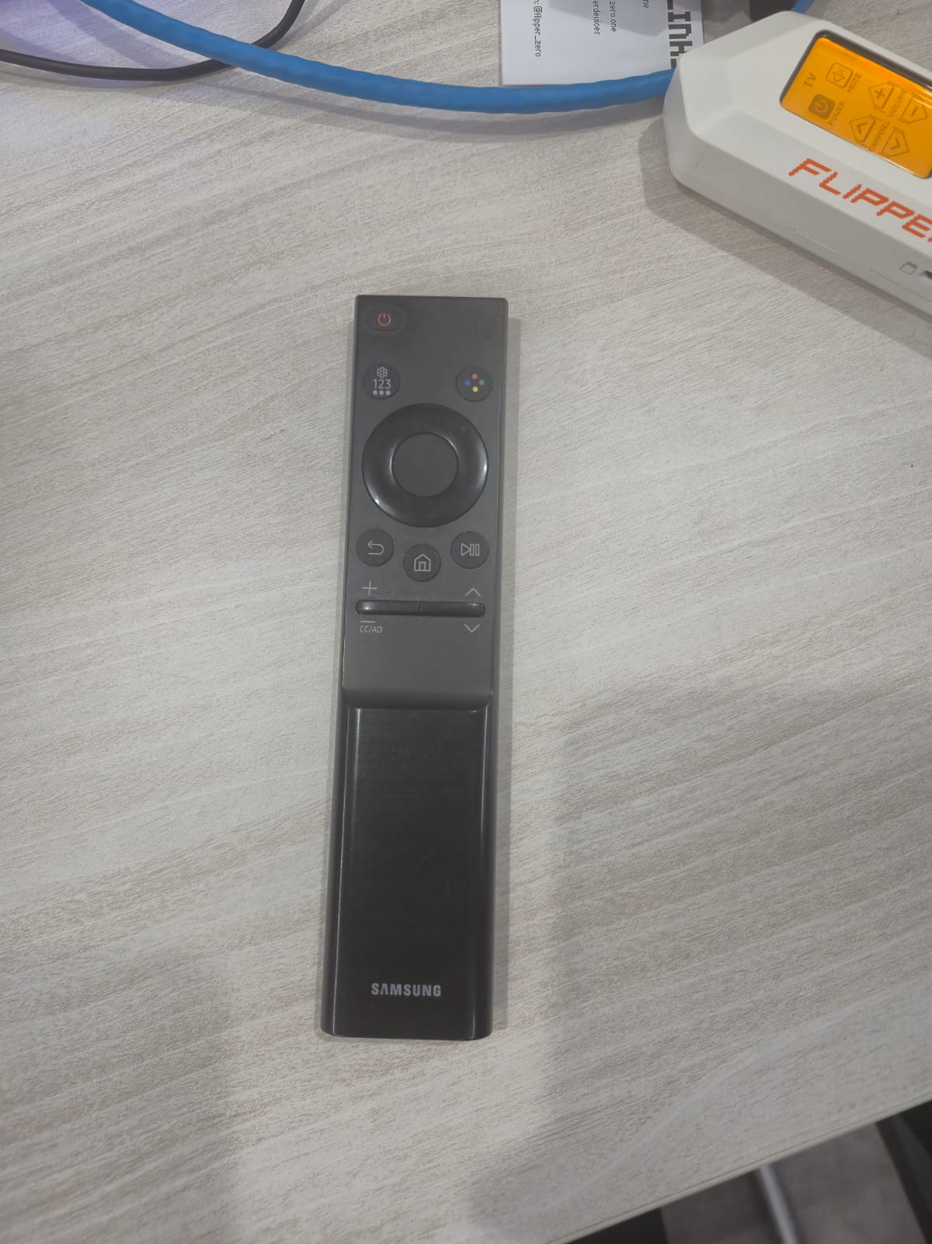
Figure 2.9 — Samsung remote beside the Flipper Zero's used to send the actual IR command.
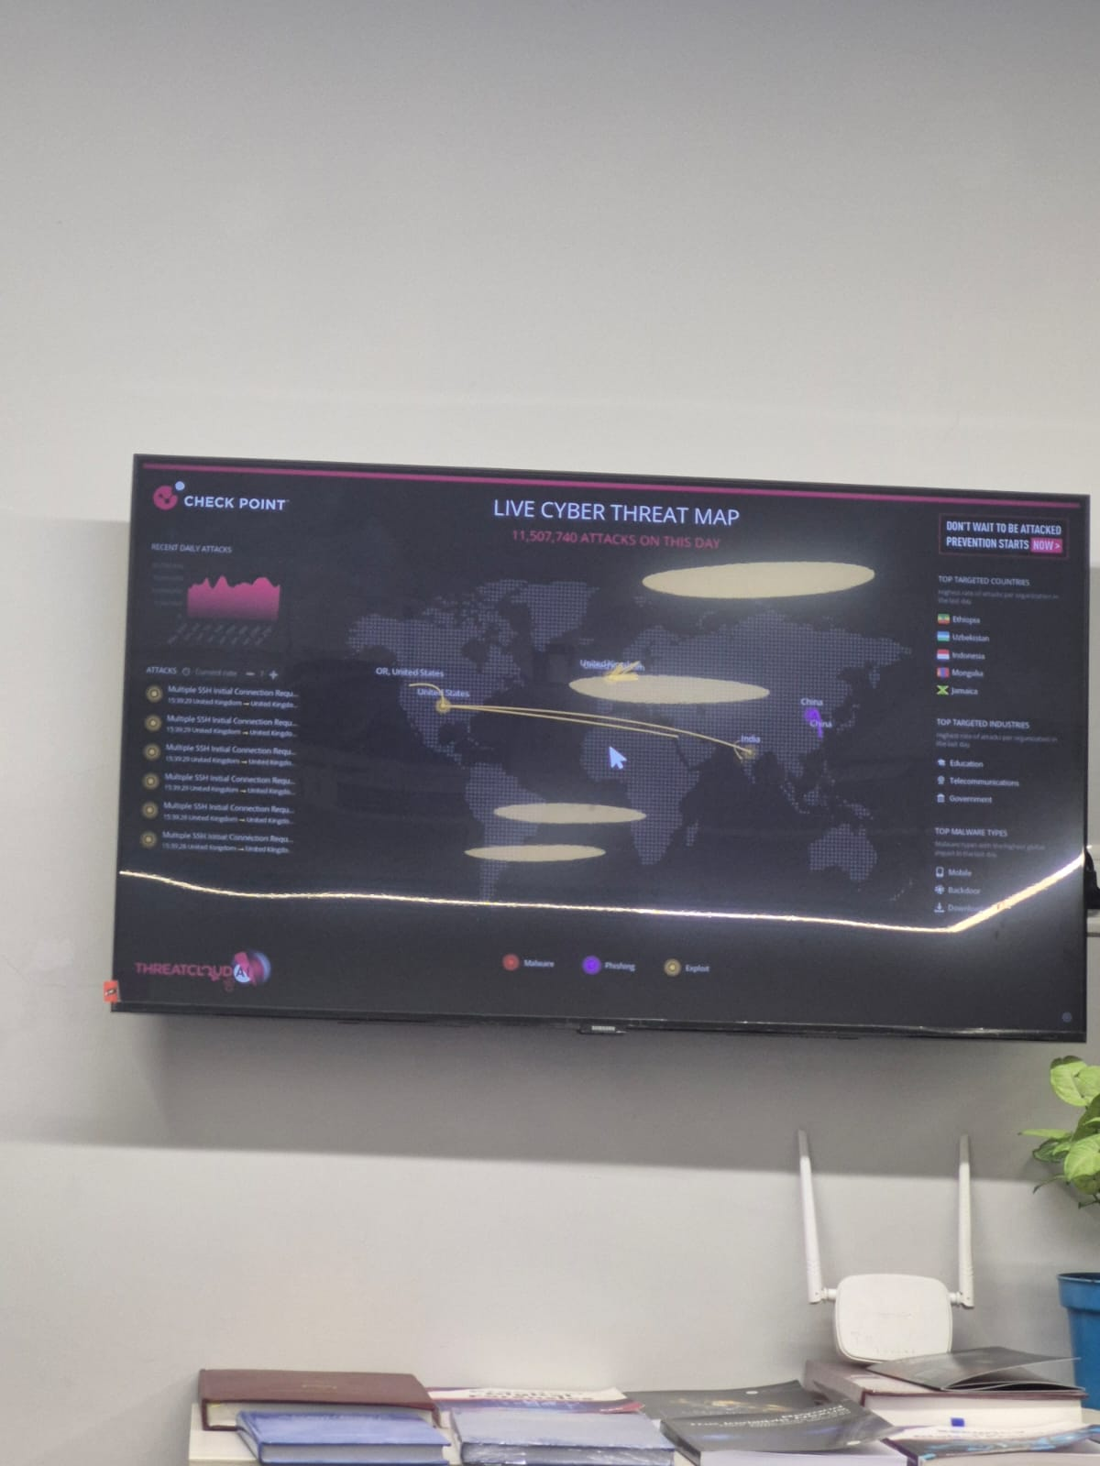
Figure 2.10 — “Before”: the TV powered on and displaying content, prior to the IR command being sent.
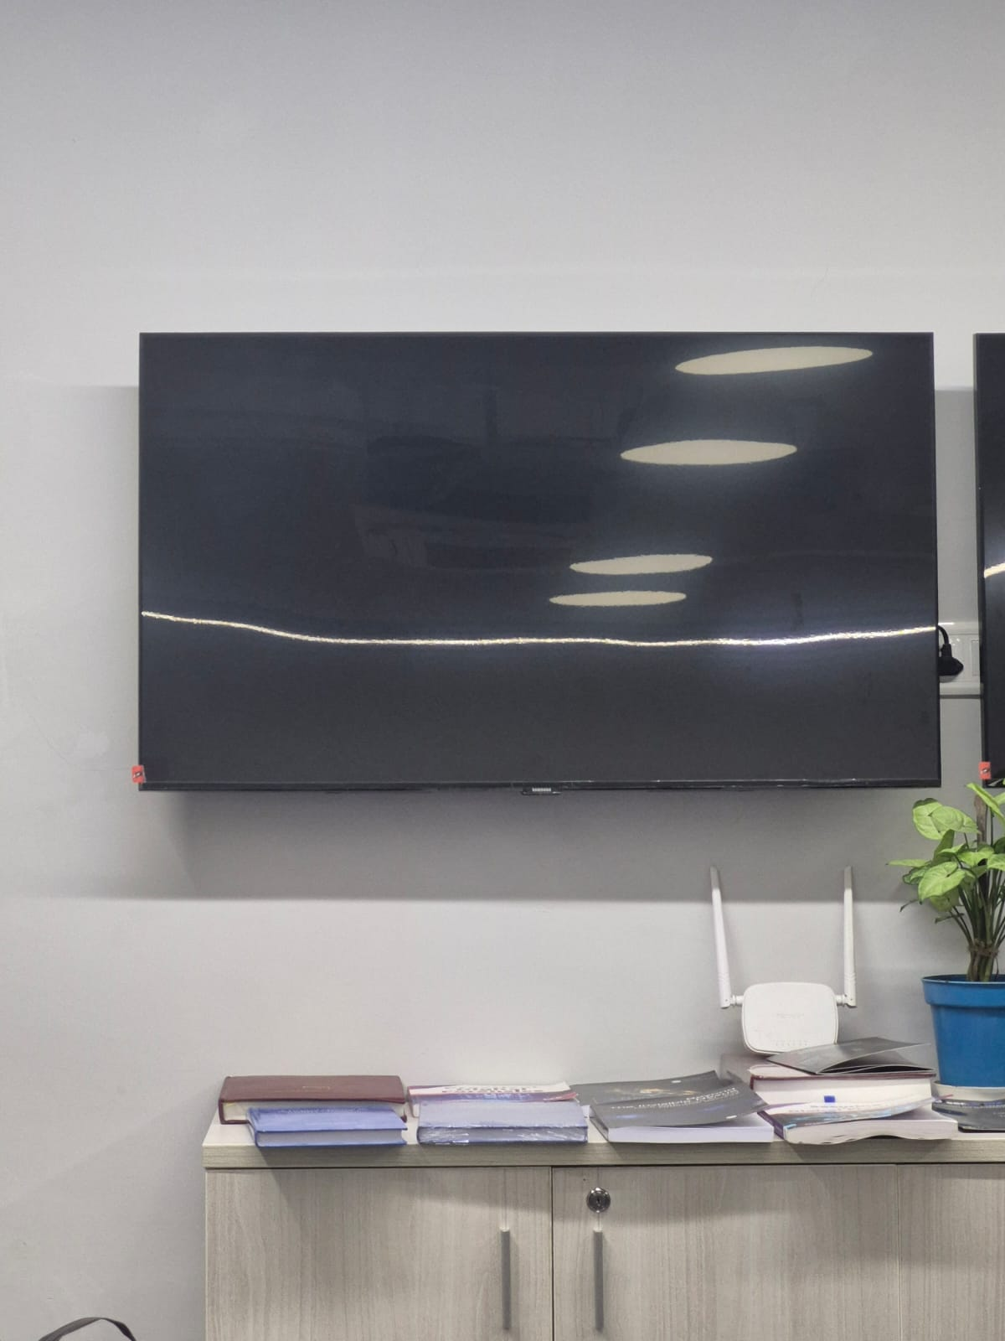
Figure 2.11 — “After”: the same TV immediately after the Power command was sent from the Flipper Zero, now blank/no-signal — confirming the IR code worked correctly.
Note: If the TV does not react the way Figures 2.10–2.11 show, double check that the IR port is aimed directly at the TV's receiver with a clear, close line of sight, then retry.

Part B: Learning a Signal from a Physical Remote
If the universal remote database does not have your exact device, or you simply want to copy a remote you already own, use Learn New Remote instead. This captures the actual signal sent by your existing remote control.

Step B1: Open “Learn New Remote”
- From the Infrared main menu, highlight Learn New Remote and press OK.
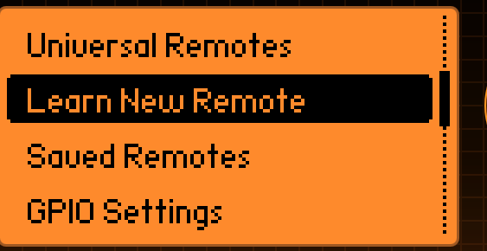
Figure 2.12 — “Learn New Remote” highlighted in the Infrared main menu.

Step B2: Aim the original remote at the Flipper Zero
Take the physical remote control whose button you want to copy.
- Point the front (the dark IR-emitting tip) of the physical remote directly at the Flipper Zero's IR receiver (top edge of the device), at a close distance — a few centimetres apart works best.
- Press and release the single button on the remote that you want the Flipper Zero to learn (for example, Power).
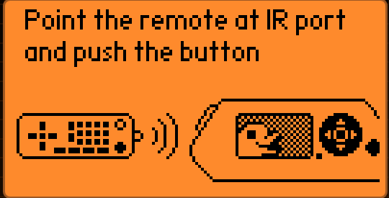
Figure 2.13 — “Point the remote at IR port and push the button.”

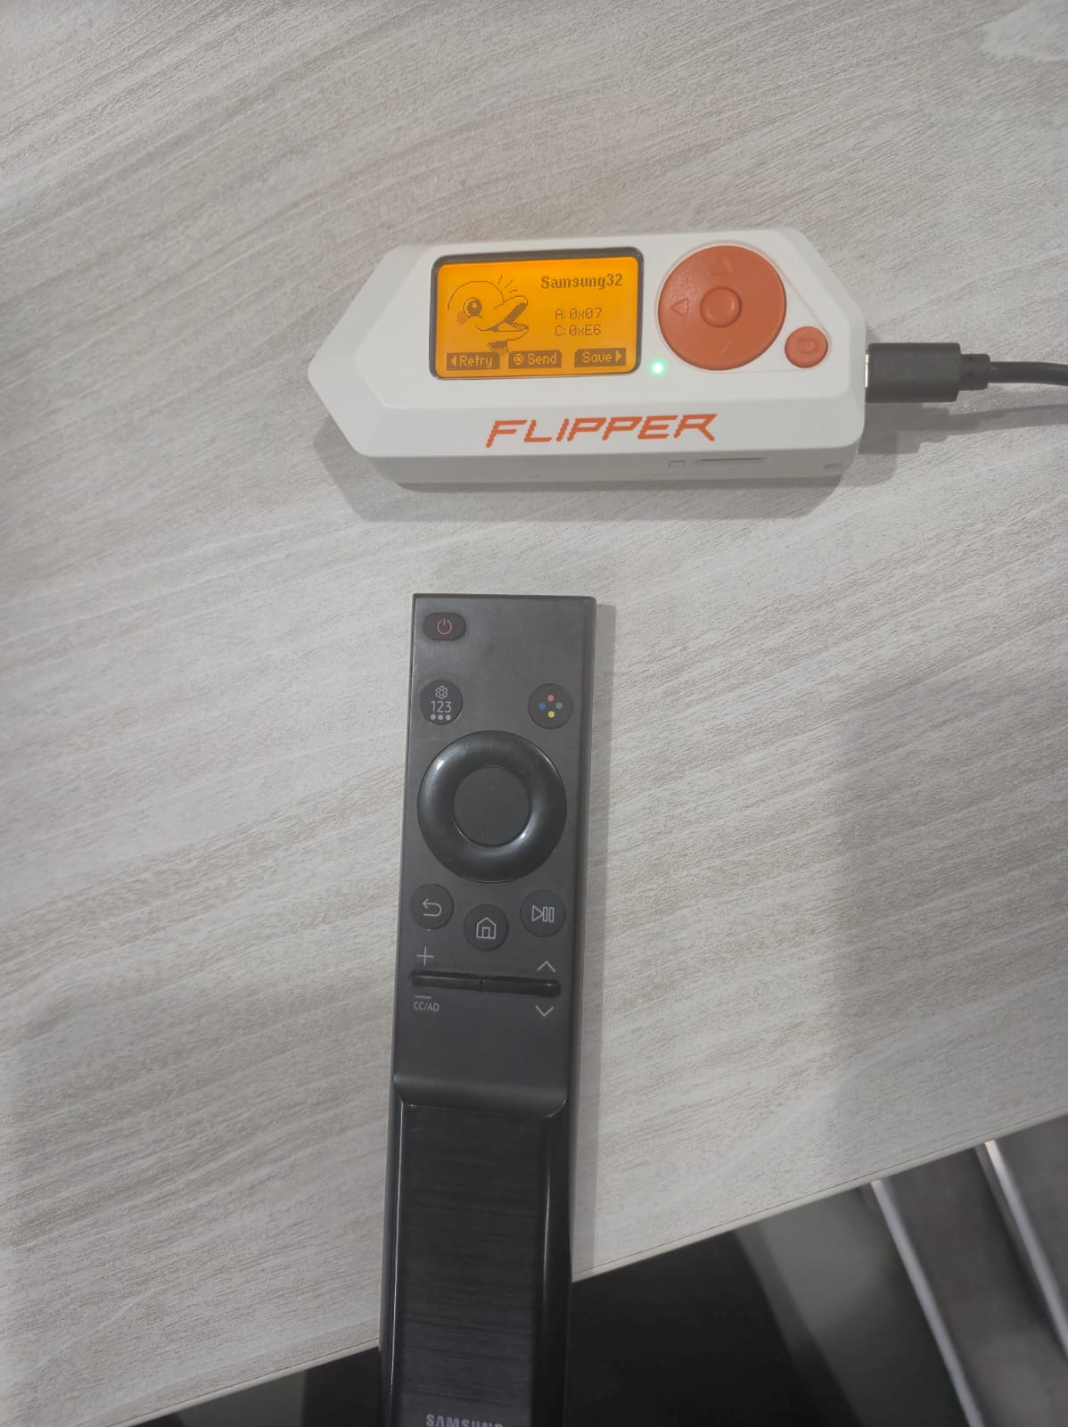
Figure 2.8 — The Flipper Zero showing the matched “Samsung32” code (A: 0x07, C: 0xE6) placed next to the original Samsung TV remote it was matched against, confirming the brand/model match.

Step B3: Name the button
After the Flipper Zero successfully captures the signal, it asks you to give the button a name, using the on-screen keyboard.
- Use the D-pad to highlight each letter and press OK to type it (a suggested name is filled in automatically, for example “Sams_E6” — you can keep it or change it).

Step A2: Choose a saved/known remote or create one

Step A4: Confirm and save the working code
- Once a code makes the device react, the Flipper Zero shows you exactly which code worked (its technical signature), along with options to Retry, Send again, or Save it for future use.
- 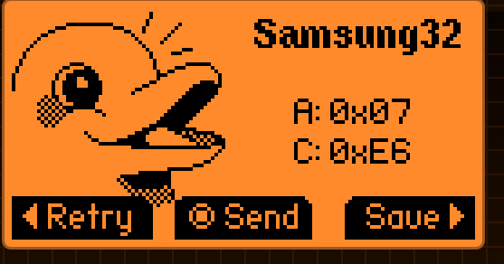
- Figure 2.7 — A working code was found for “Samsung32” (A: 0x07, C: 0xE6). Select “Save” to keep this code.
- When finished, highlight save on the keyboard and press OK.
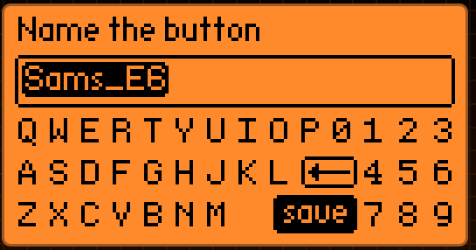
Figure 2.14 — Naming the newly learned button before saving it.

Once saving finishes, the learned button is stored under Saved Remotes in the Infrared menu, and you can send it at any time afterwards by selecting it and pressing OK.

Summary
- Universal Remote: open Infrared → Universal Remotes → pick the device category → aim at the device and send codes until it reacts → Save the working code → confirm with a live before/after test.
- Learn New Remote: open Infrared → Learn New Remote → aim the original remote at the Flipper Zero and press the button → name it → Save.

